Data visualization with R

Week 1

Introduction

- Install R and Rstudio
- Manipulate data in R
- Use functions in R
- Import data files into R
- Create visualizations using Base R

3 modules in class:
- Introduction to R
- Introduction to tiddyverse
- Introduction to Rmarkdown (Generate reproducable data reports)

Introduction to R and Software Installation

R requires you to write R code. Spreadsheets softwares like tableau, doesn’t.
Data management (wrangling) is crucial. Good management leads too instant visualization.

Rstudio is an integrated development environment (IDE). Rstudio is an editing program that make write R code easier.

Basic R, Part 1
(see basic R cheat sheet)

Write commands in the console.
Save code by creating new scrips.

Highlight commands and press shortcut (ctrl+enter) to run commands.
Comment a line by using #########. R will skip one line and run the next command.
- Strings in quotation marks
- ####save the output of a command to an object
####save the output of a command to an object
a <- 2+2
my_a <- 2+2
my.a <- 2+2
Follow with Lecture_Basic R

Classes

Data in objects, in R, are given a class (depending on the type of data inside the vertor/list). The class function will tell you which one your vector falls into.

Logical vectors: True/false value
Numeric vectors: Numbers
Character vectors: Strings(?)
Factors vectors (special type of Character vector)(tricky): character vector with ordinal value assigned to them, called levels.

Combining numbers and characters in a vector, numbers will be converted to strings, to characters.
It’s bad practice.

You can change vectors to certain classes with functions as.character(…vector to change), as.logical(…) as.numeric(...) and as.factor(…).

Functions

Set of commands to tell R, what to do with input.

See Function R file from course.

Yet, there is no need to write functions yourself. All you need to do is use the packages online.
Great code is already written and ready to use.

Use Alt + - , for <- (arrow shortcut)
Press TAB to list possible functions

Dataframes

DEF: data tables (spreadsheets) stored in R environment. (with colomn headers, titles, possibity to add or substract colomns or rows).

Create dataframes by compining vectors together.

Follow lecture in R

Run ?function_name for documentation on a function

Import data in Rstudio

Easiest kind of data to do visualization with is rectangular data (has rows and columns).
Very common type of rectangular dataset is a camma separeted values file .CSV

In session, set working directory and choose directory of .CSV files.
In linux, directory ex: ~/Documents/Carriere/GUXR/Formation/Data with R/Test R files/…

Clean data variables with broom when global environment is crowded. Run the code to get those back up in the environment.

If persisting technical problem, restart R in Rstudio in Session Restart R.
Base R visualization

When you plot data, 2 types of plot:
- Univariate: plots destribution of values of a single variables (or a single vector) in R
- Multivariate: Plots the value ou two or more values in relation to each other.

Univariate ex: Histagram. Bar chart of frequencies with different values of the vector.

Follow lecture plots in R

Generate random numbers with rnorm, rpois,rbinom and runif.

Ex: variable1 ← runif(50,0,100) . Pull 50 values randomly, between 0 and 100

You can export the graph in Plot, export, save image!

Yet, base are illustrations are not ideal. Plots are great for exploratory analysis, but are not publication ready.

Good links, but don’t try to learn everything at once!!!

http://www.cookbook-r.com/Graphs/Histogram_and_density_plot/
http://www.cookbook-r.com/Graphs/Box_plot/
http://www.cookbook-r.com/Graphs/Scatterplot/

Introducing the tidyverse and importing dataframes

data wrangling functions, reshaping to meet your needs.

DEF Tidyverse: set of R packages including many commands to manage and visualize data.

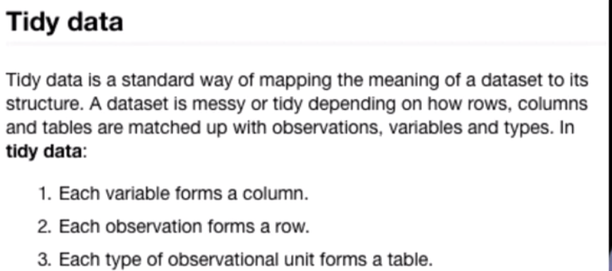
This Tidy data definition is the best possible rectangular dataset disposition.

Importing Data

installing tidyverse
Load the tidyverse library : Library(tidyverse)

Codebook: explains what all the answer means to the survey question[in csv = numbers. In codebook = answers to questions written]! CCES_sample_codebook. Ideal circumstance to finding data

Understanding documentation and codebook is essential to data wrangling. ! Good practices in data science.

In tidyverse, read_csv (R basic = read.csv) produces a tible rather than a dataframe. Tibbles work better for the tidyverse.
Ex: shows the top 10 rows, not everything (user friendly). Many features of tibbles in tidyverse prevents mistakes from user.

You can cover dataframes to tibbles and vice versa using as.data.frame() or as_tibble().

First step of wrangling data: decide on blank cells in dataset. Careful, you may have a lot of blank.
Easiest, but not necessarely best, is droping rows with blanks: drop_na()

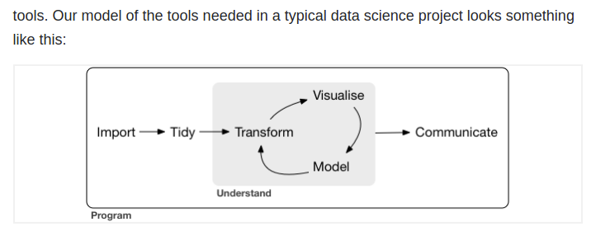

Important information about tidyverse packages:
https://tibble.tidyverse.org/
https://tibble.tidyverse.org/articles/tibble.html
https://readr.tidyverse.org/
https://readr.tidyverse.org/articles/readr.html
https://tidyr.tidyverse.org/
https://tidyr.tidyverse.org/articles/tidy-data.html

Importing data Part 2

create smaller datasets with the sections that you want with the filter function.
Filter(datasource,condition for the filter). Conditions will only pull rows that met condition in a specified column.
In lecture, filter(cces,gender==2)

dim command, for dimension of tibble.

Add 2 filters. filter(ccess,gender==2 & pid7>4)

####select certain columns from the data

select(republican_women,"educ","employ")

Piping: compining different commandes and filters to meet your needs. Piping is one line of text, combining many. %>%

####combine multiple commands using piping

#x %>% f(y) is the same as f(x, y)
#y %>% f(x, ., z) is the same as f(x, y, z)

see how to recode variables and many other wrangling commands with lecture materials

leaving values out in the recode function will be recorded as missing data. Complete directions for the function needed to recode properly. Left side of = is former value, right side of = is new desired value. ‘1’= “democrat”. Punctuation is crucial to recode.

Rename function (nameofdataset,newnametocolumn=oldnameofcolumn)

Add values & mutate… see cheat sheet or lecture video.

Arrange: quick tables, equivalent of sort(R basic). Change the order of the rows, based on the values of columns.

Group: changes how tibbles interact with other function in tidyverse. Very useful with other functions

Summarize: Reduce multiple values to one. Great in conjunction with group function. Generate summary statistics of columns in datasets, like means, medians, standard deviations, etc.

Ex: summarize(nameofdataset,nameofnewcolumn=Rfunction_tocreate_desirednumber)
Ex: summarize(cces,mean_pid7=mean(pid7))

See R for data science Book chapter reference: https://r4ds.had.co.nz/transform.html

See Dplyr Function Reference!
https://dplyr.tidyverse.org/reference/index.html#section-one-table-verbs
https://dplyr.tidyverse.org/reference/index.html#section-two-table-verbs
R markdown
Is a file containing text, but includes R code and visualization. Others can replicate, from scratch, the same process you used. .RMD, in contrast to R code files, .R.

## are not comments, its a way to format text that follows. Two pounds ## = bold header. Asteriscs ** means bold in paragraph.
R code chunks are separated by 3 apostrophes ’’’ . R code is between {…}, and a title for the r code chunk follows

echo=False . Means to hide the raw code in final document. You won’t see the code, but you will see the output.

Really powerful pdf creater, and incredible for research transperancy. Reproducable data science!

More at this link : https://r4ds.had.co.nz/r-markdown.html & https://rmarkdown.rstudio.com/lesson-1.html

R markdown format (special synthax)

See lecture’s rmd file. As example.

Put data file and RMD file in same folder! Need to be on same place.

With Knitr packages loaded, use the kable function to easily convert input to a table. Great for tables generated with table function and input with summarize function in tidyverse.

See R Markdown: The Definitive Guide - https://bookdown.org/yihui/rmarkdown/basics.html

Ggplot2

Very powerful for data visualization. Production quality visualization.

For beginners, you can use qplot (quick ggplot).

In qplot, specify x and y aesthetics. (what data to map in axes)
see lecture’s table-and figure-markdown. RMD

Then, tell qplot what figure you want to draw. Called “Geometries”. Basic: histogram, density, boxplot, point and line.
see lecture’s table-and figure-markdown. RMD

See university of california business analytics R programming guide. & also https://ggplot2.tidyverse.org/reference/qplot.html

